ADITHYA R
192311369

7. Create a Virtual Machine with 1 CPU, 2GB RAM and 15GB storage disk using a Type 2 Virtualization Software, using virtual box.
AIM:
To create a virtual machine using VirtualBox with 1 CPU, 2 GB RAM, and 15 GB storage disk.
PROCEDURE:
*Open VirtualBox and click New to create a new virtual machine.
*Enter the VM name, select the Type and Version of the operating system.
*Set Memory Size to 2 GB (2048 MB) and click Next.
*Choose Create a virtual hard disk → VDI → Dynamically Allocated → 15 GB.
*Click Create to complete VM setup.
*Go to Settings → System → Processor and assign 1 CPU, then click OK.
*Start the VM, attach the OS installation ISO, and install the operating system.

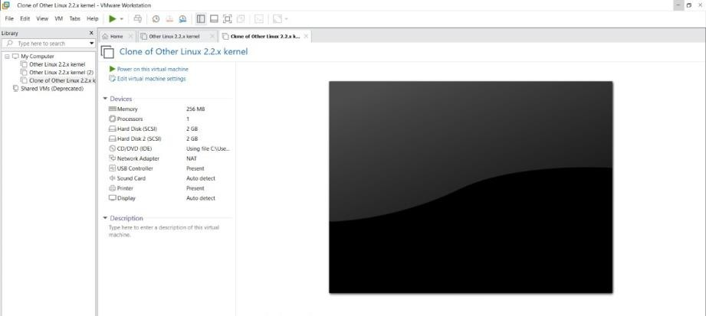



.
Result:
The virtual machine is successfully created in VirtualBox with 1 CPU, 2 GB RAM, and 15 GB virtual storage. It is ready for OS installation and can run like a normal computer inside the host system.

